AP Visibility: US Non-Merchandise AP Registration

NOTE: If you have any questions regarding the registration process, contact EasyLink Customer Support tradegateway@opentext.com

New account setup with EasyLink

NOTE: See page 5 if you already have an account with EasyLink

- Go to: https://www.enabletrading.com/sscripts100B/tg_prod.wsp/reg.htm

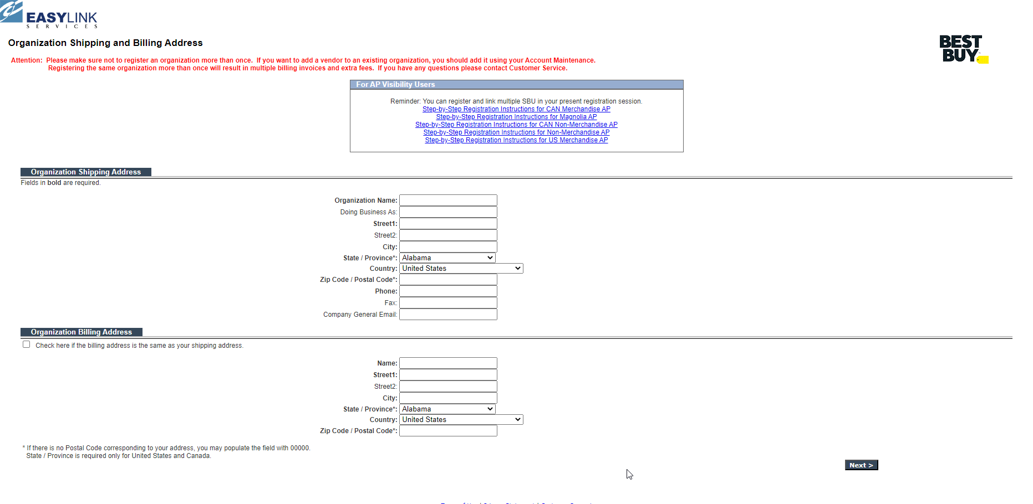

Note: The information is used only to get you through the registration process. Information should be for the person that is going to be the AP Visibility administrator for the account.

- Enter: Organization Shipping Address
- Enter: Organization Billing Address or check the box if the shipping and billing address is the same
- Select: Next

Note: The below information should be for the person that is going to be your AP Visibility system administrator.

- Enter: Organization Contact Information
- Enter: Secondary Contact if applicable
- Enter: Billing contact
  - This is for registration purposes only. There is no charge to use AP Visibility
- Select: Next

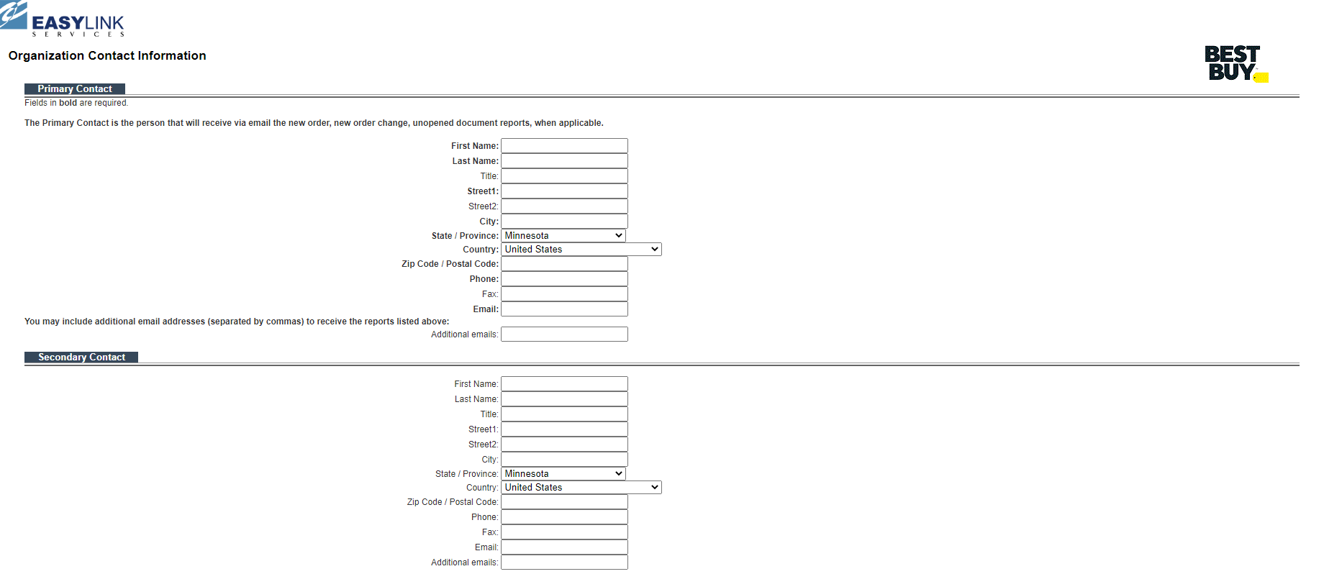
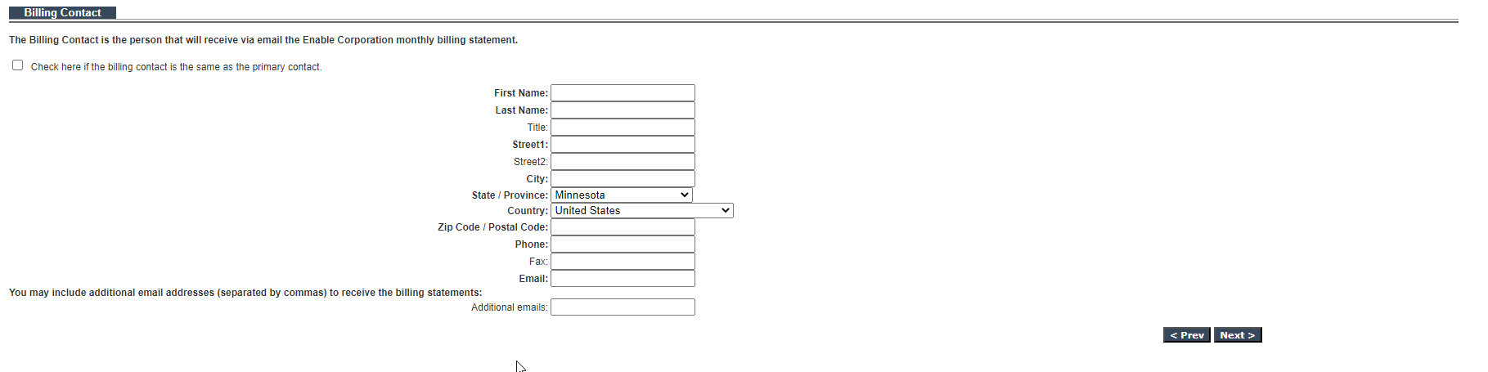

- Select: AP Visibility: US Non-Merchandise AP – DO NOT SELECT BBY CA

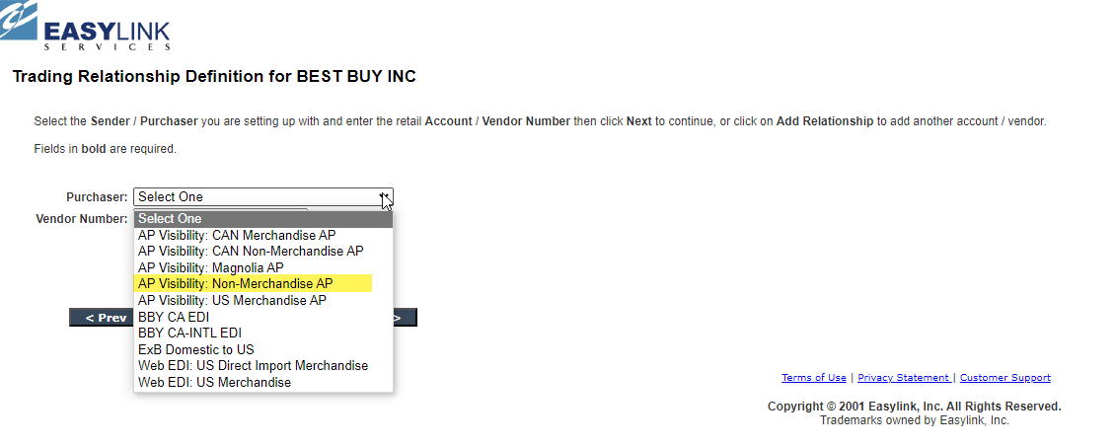
- Enter: Your account Number (9-digit number provided to you in your Welcome to Best Buy letter; included in subject line of this email).
- Select: All screens
- Select: Add Relationship

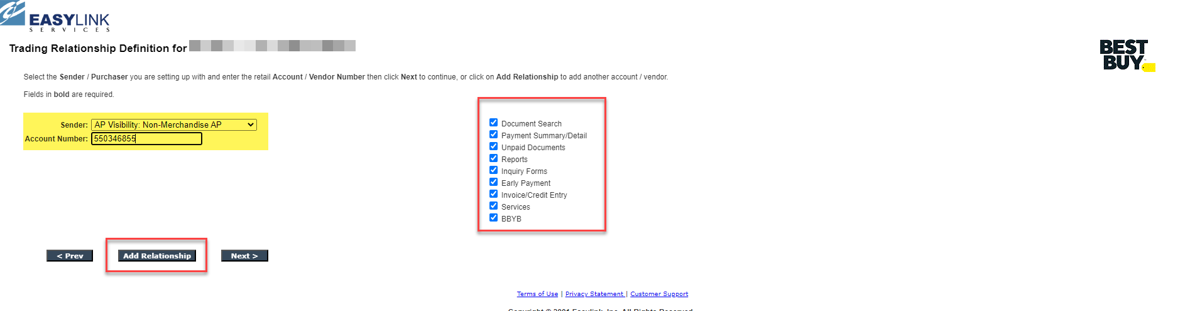

- If you have additional accounts
  - Select: AP Visibility: US Non-Merchandise AP
  - Enter: Next account number
  - Select: Add Relationship until you have added all your accounts

- Select: Next

Note: This is a free service provide to our vendors. This information is needed to process the registration.

- Enter Promotion Code: BBYSIS
- Select: Check or Money Order (By entering the information in this format, the organization will bypass any fees)

- Select: Next
- Create User Name: Suggestion enter “Organization Name”
- Create User ID: Suggestion enter Users First Initial and Last Name
  - When access is received, this will be your login ID (or user name)
  - Password will be generated and sent via email once you are approved

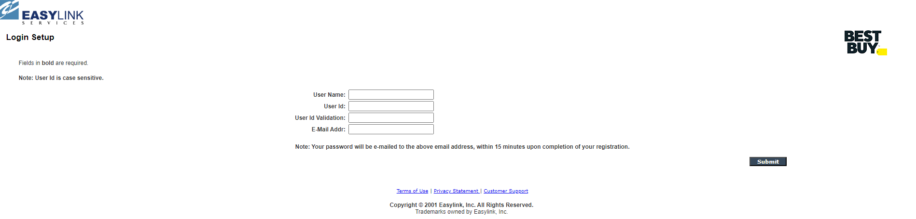

- Select: Submit
- Registration is complete message:

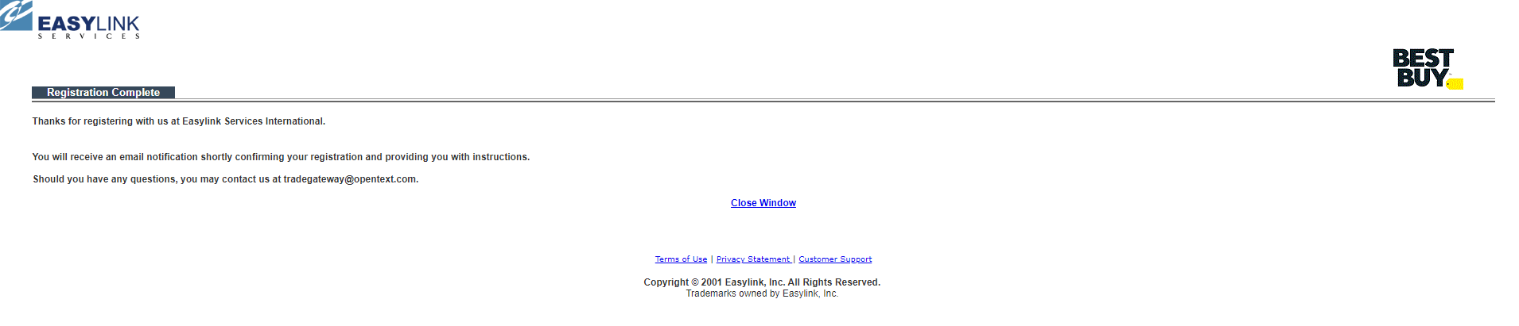

An email will be sent to Best Buy to validate and approve registration. You will receive an email from EasyLink once the registration has been approved which will include your temporary password.

Once you have received confirmation that your account has been activated, you can now add other users
- From the Home Page, select: Account Maintenance
- From drop down, select: Login/Module Maintenance
- Select: Go
- Select: Login

Go to account maintenance and select ‘Add Login.’ If you have further questions, contact EasyLink Customer Support.

If you already have an account with EasyLink:

Select: https://www.enabletrading.com/scripts/tg_prod.wsp/logon.htm
From Home page on EasyLink
- Under Account Management section, select: Account Maintenance

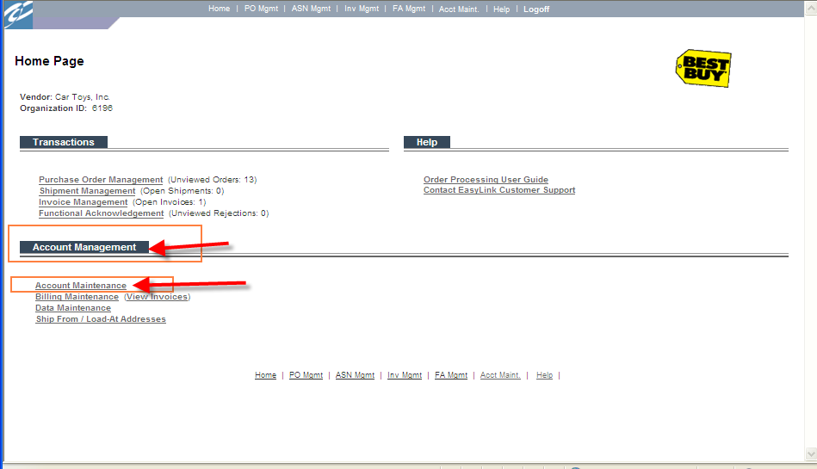
At the Trade Relationship Management window, scroll down to the bottom of the screen
Select: Register For Another Best Buy Corporate Entity 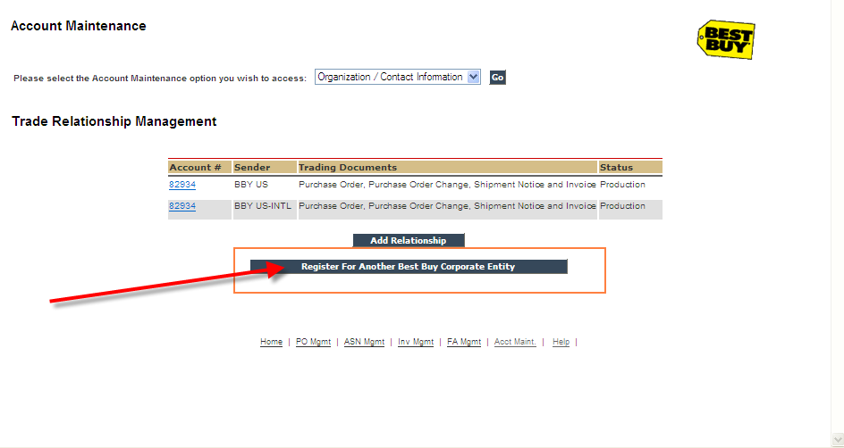
From the Purchaser list, select: AP Visibility: US Non-Merchandise AP
Enter the account number that you want registered for AP Visibility. This step will need to be done for each account that you want registered for AP Visibility.

If you have any problems registering your accounts, contact: AccountsPayable@bestbuy.com
Once you have received confirmation that your account has been activated, you can add other users
- From the Home Page, select: Account Maintenance
- From drop down, select: Login/Module Maintenance
- Select: Go
- Select: Login

Go to account maintenance and select ‘Add Login.’ If you have further questions, contact EasyLink Customer Support.

